**Lauhaus Clay Extruder 0.1 Bill of Materials**

*with helpful links and counterproductive observations*

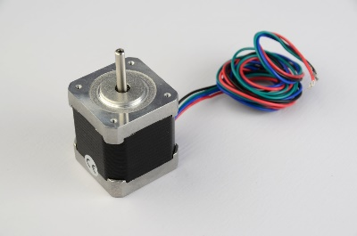

One Nema 17 Motor – the most common motor used in RepRap printers. Available in many locations. I buy mine from Lulzbot: <https://www.lulzbot.com/products/nema-17-stepper-motor> . These can also sometimes be found inside of old document scanners if you like breaking things.

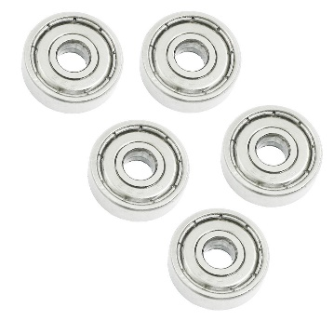

One 625ZZ Bearing 5mm x 5mm x 16mm – These are very common in skateboard wheels and are very cheap – usually less than 1 dollar per. Should be in stock at your local skate shop. Also at Amazon: <http://www.amazon.com/Skateboard-Groove-Radial-Bearings-625ZZ/dp/B009EPNW8Y/ref=sr_1_3?s=industrial&ie=UTF8&qid=1446838234&sr=1-3&keywords=625zz>

https://img3.fastenal.com/productimages/30134.jpg

One wood screw. The first one I tried was 14 guage (1/4inch diameter (6.3mm metric)) and was three inches long. I cut the head off with a dremel cut off wheel. This screw worked, but I’m certain there ae better augers out there. I plan to experiment with a range of screws, drill bits, etc. Also I’m not sure why something labeled ¼” (6.3mm) was able to fit in the bearing’s 5mm hole. I sanded it a bit, but not that much. I think screws are highly variable by manufacturer and that their dimensions are sometimes more nominal than actual – at least in my neck of the woods. [Here’s one similar to mine](https://www.fastenal.com/products/details/1130238?r=~|categoryl1:%22600000%20Fasteners%22|~%20~|categoryl2:%22600051%20Screws%22|~%20~|categoryl3:%22600071%20Wood%20Screws%22|~%20~|sattr02:%5eSteel$|~%20~|sattr03:%5eFlat$|~%20~|sattr04:%5ePhillips$|~%20~|sattr05:%5e%229pound14%20-%2010%22$|~%20~|attrlength:1630|~).

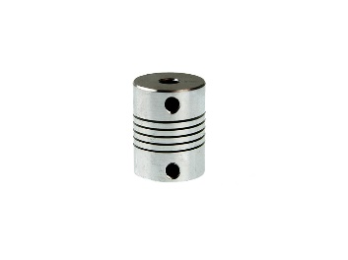

One flexible coupler. – 5mm holes – This attaches the screw to the motor shaft. These can be purchased online, [here’s where mine came from](https://www.inventables.com/technologies/flexible-coupler). That said, I always liked the way the Prusa i3 printer originally used a [piece of tubing instead of a coupler](http://3.bp.blogspot.com/-Z1Y2iyhLs8A/UhL_BsgxiFI/AAAAAAAAF6w/BmKeCiHRCiw/s1600/Prusai3-metalframe.jpg). So maybe this coupler is a bit too esoteric for my design – it may not be necessary – I’m going to try alternatives.

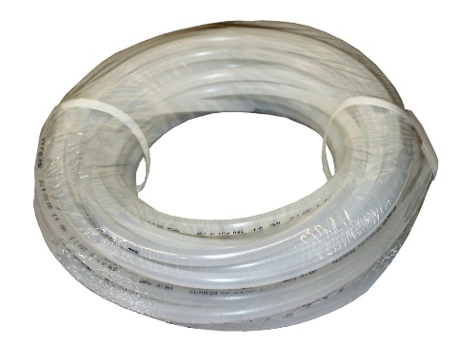

Flexible tubing (to from feed tank to extruder head) I used some that had an inside diameter of 3/8” and an outside diameter of ½”. The WASP project uses 12mm tubing, which I’m guessing is essentially the exact same diameter. I used regular plastic tubing from the local hardware store. This was a bad choice! The WASP project uses Teflon (ptfe) tubing – which I’m sure significantly reduces drag on the clay moving through the tube. I’m going [to buy some Teflon tube from here](http://www.mcmaster.com/#5033k35/=zp269m). Actually, on second thought, that is annoyingly expensive tubing. I may go over to the part of my campus where the cows are kept and milked (hundreds of them) and ask around about what type of tubing has the least friction. Then I’m going to get Ice Cream.

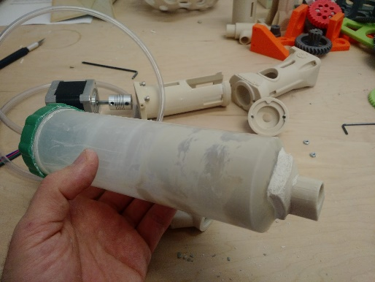

Clay holding/Feed tank. I repurposed this one from the Jonathan Keep printer bill of materials. I cut off the luer lock syringe tip, drilled the hole out to ½ inch and 3d printed anew nozzle fitting for it which I epoxied on with PC-11 epoxy. This is not an ideal solution! I mean it worked fine, but its smallish and why buy a thing just to cut it up and glue printed parts to? Look how nice the WASP project tank is (lower right):

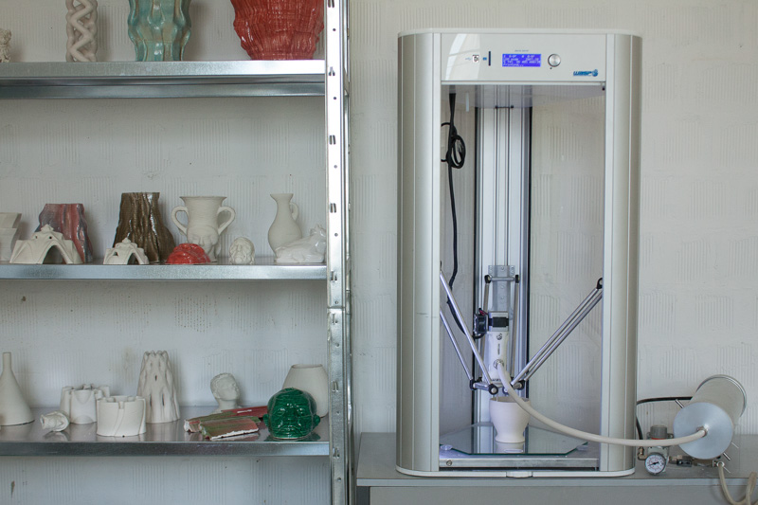

That said, I actually have a grudge against the pneumatic holding tank aspect of the project. I really want to design and build a mechanical tank – a stepper motor driven plunger. For two reasons:

1. To be able to modulate feed rate and pressure via software/firmware.
2. Air compressors are expensive, large, and noisy.

More on this later – but eliminating all compressed air from the system is a goal of mine.

That’s everything (+ the three 3d printed parts (extruder shell, extrude cap, part that does the work).